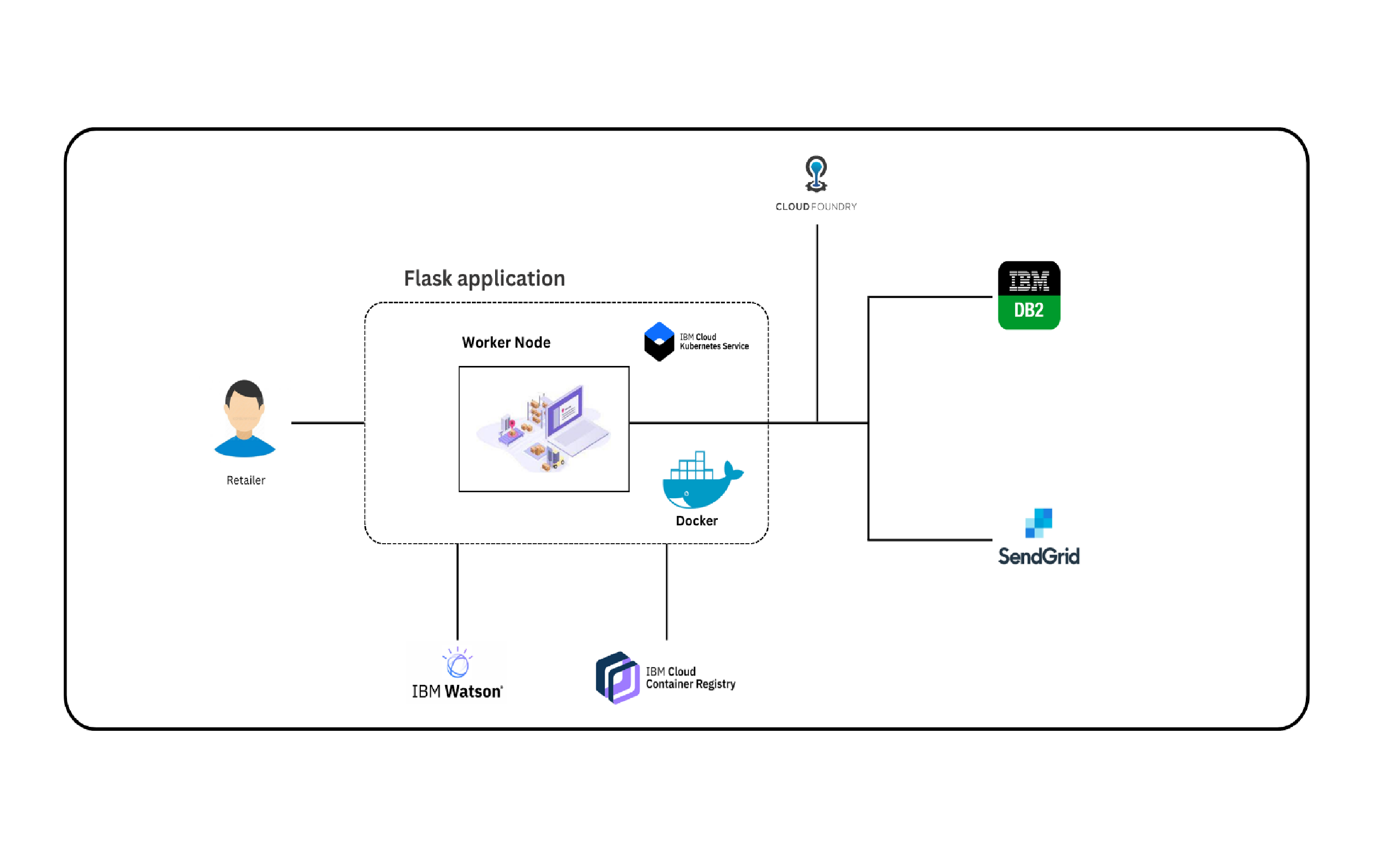Project Design Phase-I Solution Architecture

|  |  |
| --- | --- |
| Date | 27 September 2022 |
| Team ID | PNT2022TMID07849 |
| Project Name | Inventory Managment System for Retailers |
| Maximum Marks | 4 Marks |